HotHouse Theatre
4 Broad Walk, Nottingham, NG6 0LL Tel 07804652459 Co No 06505843 Charity No 1154523

HotHouse Theatre Child Safeguarding Policy.

Up dated 17/01/2023
Reviewed 24/11/2023

Statement;
It is the policy of HotHouse Theatre to safeguard children from all forms of abuse and harm while participating in activities relating to the work of HotHouse Theatre.

We will take all reasonable steps to ensure that this can be achieved.

For the purposes of this statement and the policy, children are any persons under the age of 18 years.

Policy
HotHouse Theatre is likely to work with children in two ways. As part of projects not specifically aimed at children, and projects which are specifically aimed at children.

- Projects not specifically aimed at children.

On such projects, where there will be adults also involved in the project, children will be accompanied by a chaperone, which can include members of their own family. The chaperone will take responsibility for the welfare of the young person.

All involved in the project will be expected to follow the policy of ensuring that the young person is protected from abuse and harm.

- Projects aimed at children.

All staff, volunteers and trainees will be expected to go through a DBS check which is reviewed every 3 years.

They will not be allowed to work unsupervised with children until they have been cleared through the DBS check system.

Ratios of Staff/volunteers to children or vulnerable adults will be at least 2 to 12.

Parents Guardians or chaperones will be responsible for getting children to and from the venues.

Written permission from parent or guardian is required before a child can be included on a project.

Safeguarding children is the responsibility of everyone. These guidelines are for the use of all paid staff, volunteers and visitors. HotHouse recognizes its responsibility to safeguard and promote the welfare of children within the legal framework of the Children Acts 1989 and 2004.Under the terms of the Children Act 2004 anyone under the age of 19 is considered to be a child/young person.

Hothouse Theatre projects may also take place online. All online sessions involving children and vulnerable people will follow Hothouse Theatre’s Online Session Protocol.
The following protocol is to be followed during online sessions involving young and vulnerable people engaging in Hothouse Theatre’s online sessions.
In order to provide your child with this online ‘live’ session, we will need your permission so I would be grateful if you would read the this protocol and complete the online Consent Form.
We will be using Zoom Conference for the online sessions, so it is important that you ensure that you have access to facilities that will allow you to access Zoom. Feel free to contact us if you have a problem.
The Young people attending the sessions will:
- Be appropriately clothed – not in nightwear etc.
- Be in a communal area of the house, e.g. lounge, dining room, kitchen.
- Have appropriate equipment required.
- Join 1 minute before the start time – the workshop leader will admit the young person when the session is ready to start.

Parent(s)/guardian(s) will:
- Receive an email asking for their consent to allow their child/ren to take part in the online session.
- Ensure that consent form has been complete and returned.
- Be responsible for the behaviour of the young people during the on-line remote session.

The Workshop Leader will:
- Book the sessions in advance with parents
- Be appropriately clothed for the lesson.
- Be in a communal area e.g. lounge, dining room, kitchen.

Each session will have:
- a unique session ID
- a unique session password

The young people will be sent an invitation with the session ID and password via email.

Working Together to Safeguard Children defines Safeguarding as:
- Protecting children from maltreatment;
- Preventing impairment of children's health or development;
- Ensuring that children grow up in circumstances consistent with the provision of safe and effective care; and
- Taking action to enable all children to have the best outcomes.
During the covid-19 pandemic, face to face sessions will follow Hothouse Theatre’s protocol for safe working during covid-19.

Definitions of Abuse- as in the UK Government Guidance Working Together to Safeguard Children 2010(1.33-1.36)
- Physical
- Emotional
- Sexual
- Neglect

We are aware that many children are the victims of different kinds of abuse and that they can be subjected to social factors that have an adverse impact upon their lives including –
- domestic violence,
- substance misuse,
- bullying,
- child prostitution
- ritualistic abuse
- child sexual exploitation
- radicalisation .

We aim to create a safe environment within which children can thrive and adults can work with the security of clear guidance.
We will make this guidance available to the parents and carers of the children to whom we offer a service.
HotHouse will endeavour to ensure that:
- Children are listened to, valued and respected
- Staff are aware of the need to be alert to the signs of abuse and know what to do with their concerns
- All paid and unpaid staff are subject to rigorous recruitment procedures
- All paid and unpaid staff are given appropriate support and training

All child protection concerns should be acted upon immediately.
If you are concerned that a child might be at risk or is actually suffering abuse, you should tell the C. E. O. , Guy Jones .
It is important that you keep a written record of any physical or behavioural signs and symptoms. In this way you can monitor whether or not a pattern emerges and provide evidence to any investigation if required.

If the C. E. O. is not available, speak to a Trustee.
In an emergency situation contact the Multi-Agency Safeguarding Hub 0300 500 80 80 or Police on 999
-
NSPCC Helpline - 0808 800 500
GUIDELINES

RECOGNISING SIGNS OF ABUSE
It can often be difficult to recognize abuse. The signs listed in these guidelines are only indicators and many can have reasonable explanations. Children may behave strangely or seem unhappy for many reasons, as they move through the stages of childhood or their families experience changes. It is important to have some understanding of signs that could indicate abuse is taking place and to know the actions to take and who to consult further with or take advise.
- Someone can abuse a child by actively inflicting harm or by failing to act to prevent harm.
- Abuse can take place within a family, in an institutional or community setting, by telephone or on the Internet.
- Abuse can be carried out by someone known to a child or by a complete stranger.

- Physical Abuse
Physical abuse can involve hitting, shaking, throwing, poisoning, burning, scalding, drowning, and suffocating. It can also result when a parent or carer deliberately causes the ill health of a child in order to seek attention; this is called fabricated illness or Munchhausen’s Syndrome by Proxy.
Symptoms that indicate physical abuse include:
- Bruising in or around the mouth, on the back, buttocks or rectal area
- Finger mark bruising or grasp marks on the limbs or chest of a small child
- Bites
- Burn and scald marks; small round burns that could be caused by a cigarette
- Fractures to arms, legs or ribs in a small child
- Large numbers of scars of different sizes or ages

- Emotional Abuse
Emotional abuse happens when a child’s need for love, security, praise and recognition is not met. It usually co-exists with other forms of abuse. Emotionally abusive behaviour occurs if a parent, carer or authority figure is consistently hostile, rejecting, threatening or undermining. It can also result when children are prevented from social contact with others, or if developmentally inappropriate expectations are imposed upon them. It may involve seeing or hearing the ill-treatment of someone else.
Symptoms that indicate emotional abuse include:
- Excessively clingy or attention-seeking behaviour
- Very low self esteem or excessive self-criticism
- Excessively withdrawn behaviour or fearfulness; a ‘frozen watchfulness’
- Despondency
- Lack of appropriate boundaries with strangers; too eager to please
- Eating disorders

- Sexual Abuse
Sexual abuse involves forcing or enticing a child or young person to take part in sexual activities, whether or not the child is aware of what is happening. This may include physical contact, both penetrative and non-penetrative, or involve no contact, such as watching sexual activities or looking at pornographic material. Encouraging children to act in sexually inappropriate ways is also abusive. Under the Sexual Offences Act 2003, any sexual activity –contact or non-contact – with a child under the age of 13, is a crime.
Symptoms of sexual abuse include:
- Allegations or disclosure
- Genital soreness, injuries or discomfort
- Sexually transmitted diseases; urinary infections
- Excessive preoccupation with sexual matters; inappropriately sexualized play, words or drawing
- A child who is sexually provocative or seductive with adults
- Repeated sleep disturbances through nightmares and/or wetting

Older children may additionally exhibit:
- Depression
- Drug and/or alcohol abuse
- Eating disorders; obsessive behaviours
- Self mutilation; suicide attempts
- School/peer/relationship problems

- Neglect
Neglect is the persistent failure to meet a child’s basic physical and/or psychological needs, causing damage to their health and development. It may involve a parent or carer failing to provide adequate food, shelter or clothing, failing to protect a child from harm or danger, or failing to access appropriate medical care and treatment when necessary. It can exist in isolation or in combination with other forms of abuse. Symptoms of physical and emotional neglect can include:
- Inadequate supervision; being left alone for long periods of time.
- Lack of stimulation, social contact or education.
- Inadequate nutrition, leading to ill-health.
- Constant hunger; stealing or gorging food.
- Failure to seek or to follow medical advice such that a child’s life or development is endangered.
- Inappropriate clothing for conditions.

Some members of our communities hold beliefs that may be common within particular cultures but which are against the law in England. HotHouse does not condone practices that are illegal or harmful to children.
Examples of particular practices are:
- Forced Marriages No faith supports the idea of forcing someone to marry without their consent. This should not be confused with arranged marriages between consenting adults.
- Under-age Marriages In England, a young person cannot legally marry or have a sexual relationship until they are 16 years old or more
- Female Circumcision This is against the law yet we know that for some in our communities it is considered a religious act and a cultural requirement. It is also illegal for someone to arrange for a child to go abroad with the intention of having her circumcised.
- Ritualistic Abuse Some faiths believe that spirits and demons can possess people (including children). What should never be condoned is the use of any physical violence to get rid of the possessing spirit. This is physical abuse and people can be prosecuted even if it was their intention to help the child.

WHAT TO DO IF YOU HAVE CONCERNS
In the event that a child makes an allegation or disclosure of abuse against an adult or another child or young person, it is important that you:
- Let them know that you will need to tell someone else in order to help them. Do not promise to keep what they tell you secret.
- Listen to them and/or closely observe their presentation and behaviour
- Let them know that you take what they are saying seriously.
- Do not attempt to question or interview them yourself.
- Inform your designated child protection officer as soon as possible.
- Make a written record of the incident or events.

Sometimes you may just feel concerned about a child but do not know whether to share your concerns or not. In this situation you should always raise your concerns with your designated child protection officer, who will help you to decide what to do.
The responsibility for investigating allegations of abuse, whether they result from the disclosure of a child or the concerns of an adult, lies with social workers and the Police Child Abuse Investigation Team.
It is normally the responsibility of the C. E. O. to make a referral to these agencies, but if you judge the situation to be an emergency and/or you require urgent advice in the absence of the C. E. O., you must report your concerns directly, using the contacts listed in these guidelines.

The Duty social worker or CPA will advise you when or whether to inform the child’s parents or carers about any concerns. If they decide to pursue a child protection investigation, you should:
- Work closely and collaboratively with all professionals involved in the investigation, in order to keep the child safe.
- Attend a child protection conference if you are invited. You will be asked to provide information about your involvement with the child, which is why it is important to keep records of your concerns.
- Attend any subsequent child protection review conference.

ALLEGATIONS MADE AGAINST STAFF OR VOLUNTEERS
Organizations that work or come into contact with children need to be aware of the possibility that allegations of abuse will be made against members of their staff. Allegations can be made by children or concerned adults. Allegations can be made for a variety of reasons. Some of the most common are:
- Abuse has actually taken place.
- Something happens to a child that reminds them of an event that happened in the past – the child is unable to recognize that the situation and the people are different.
- Children can misinterpret your language or your actions because they are reminded of something else.
- Some children know how powerful an allegation can be; if they are angry with you about something they can make an allegation as a way of hitting out.
- An allegation can be a way of seeking attention.

All allegations should be brought to the notice of the C. E. O. immediately. In cases where the allegation is made against this person, the complainant should approach a trustee or take the following action him or herself:
- Make sure that the child in question is safe and away from the alleged abuser.
- Contact the Children’s Service Referral & Assessment Team relevant to where the child lives.
- Contact the parents or carers of the child if advised to do so by the social worker/officer in charge of allegations.

PRACTICE TIPS
Irrespective of any investigation by social workers or the police, you should follow the appropriate disciplinary procedure; common practice is for the alleged

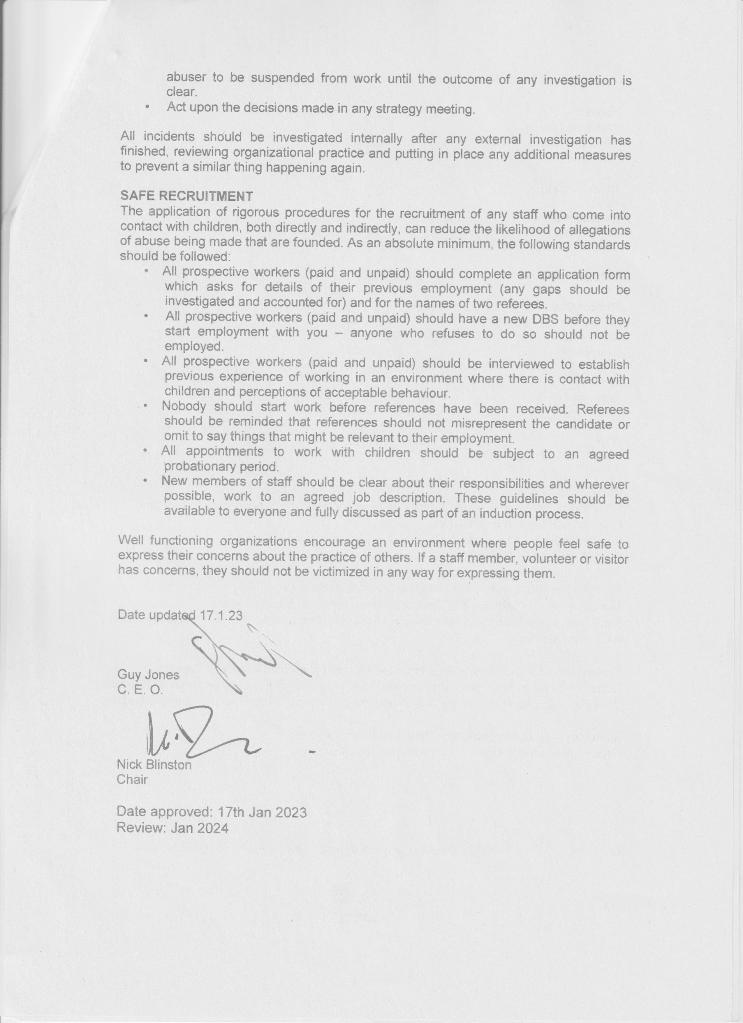

Flow chart for reporting safeguarding concern.
Name | Role | Contact Information
Guy Jones | C. E. O. | 07535138506
Nick Blinston | Chair of Trustees | 07948984403
Gareth Jones | Treasurer | 07855744196
Alex Young | Secretary | 07791321034
Hugh Jenkins |  | 07740095498

Trustees to be made aware of alert who agree with Coordinator follow up action
Concerns to be reported by Coordinator or Trustee to Multi-Agency Safeguarding Hub 0300 500 80 80
Immediately inform Coordinator or if they are unavailable a Trustee
Immediately contact police on 999.
Alert C. E. O. or if they are not available a Trustee.
No
Yes
Is the young person in immediate risk of harm?
You become aware of a safeguarding concern or a young person discloses to you

